Service Manual in Web CMS

Service Manual has been improved for your better support.

For accessing service manual, please login into WWW.VGSERVICE.CO.IN
Then click on Service Manual Tab from the menu.
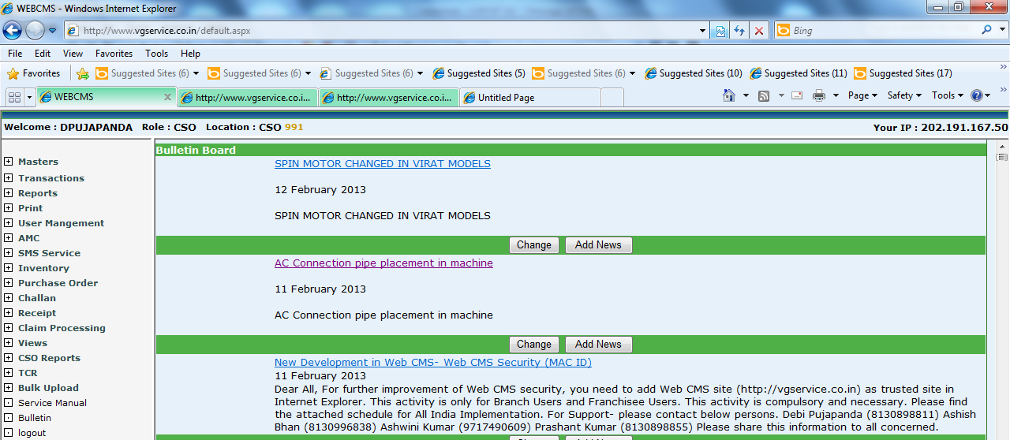
A new Pop Up will appear for Technical Manual
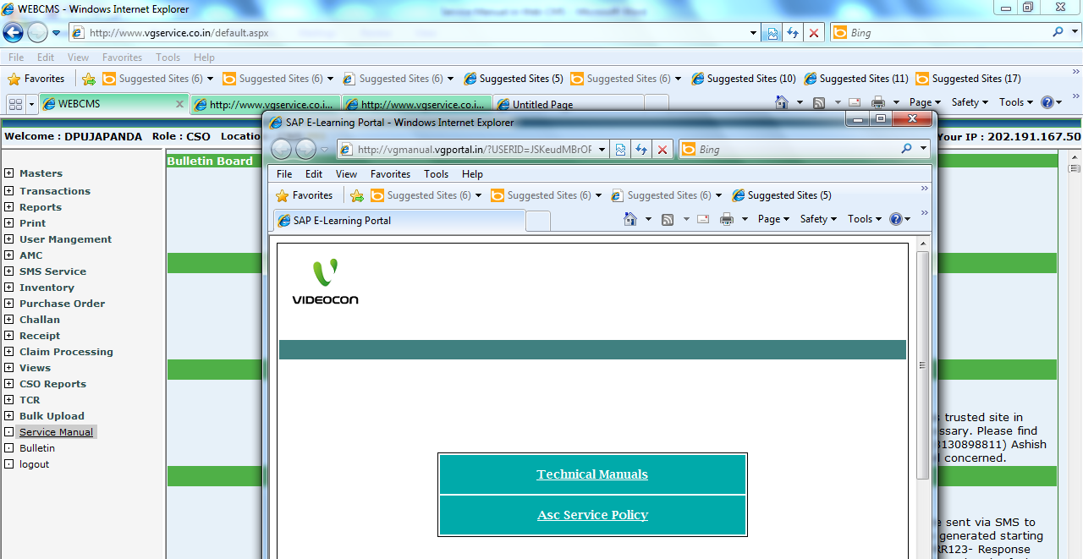
Click on Technical Manual below screen will come

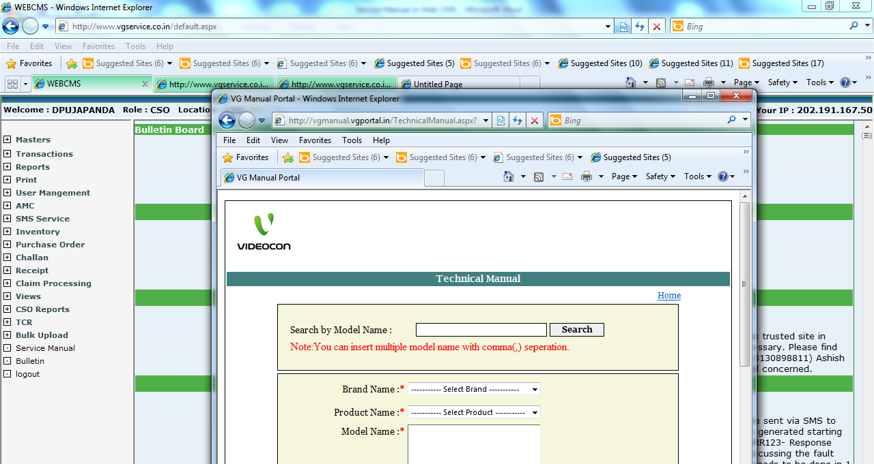
Searching can be done in two ways.
- By given complete model name
- By dropdowns
Please do not use link…
http://vgmanual.vgportal.in/?USERID=JSKeudMBrOPLD3PSJWKaWA==

